**Project Development Phase**

**Delivery of Sprint - 4**

| **Date** | **09 November 2022** |
| --- | --- |
| **Team ID** | **PNT2022TMID13205** |
| **Project Name** | **AI-based discourse for Banking Industry** |

**Creating Assistant & Integrate With Flask Web Page You will be creating a banking bot in this activity that has the following capabilities**

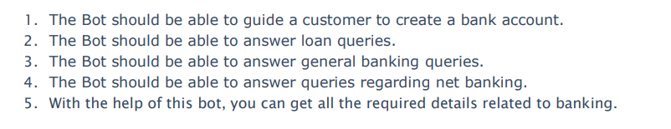

Let us build our flask application which will be running in our local browser with a user interface.

In the flask application, users will interact with the chatbot, and based on the user queries they will get the outcomes.

**Build Python Code 1:**

**Importing Libraries**

The first step is usually importing the libraries that will be needed in the program.



Importing the flask module into the project is mandatory. An object of the Flask class is our WSGI application. Flask constructor takes the name of the current module ( name ).

**2: Creating our flask application and loading**



**3: Routing to the Html Page**

Here, the declared constructor is used to route to the HTML page created earlier. The ‘/’ route is bound with the bot function. Hence, when the home page of a web server is opened in the browser, the HTML page will be rendered.

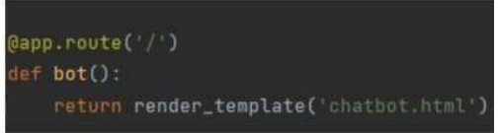

**Main Function**

This is used to run the application in localhost

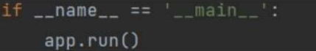

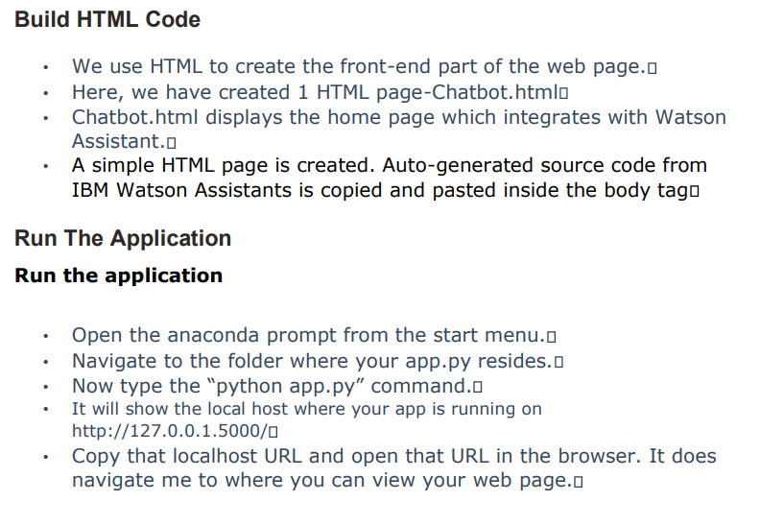

Then it will run on localhost:5000

